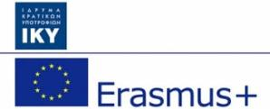
The Music School of Corinth within the framework of the Erasmus+ program, participated together with the partner schools from Italy, France, Scotland, Lithuania and Spain in the European programme “Looking Out , Looking In”. The programme started in 2020, a year with too many restrictions imposed due to Covid 19, which created difficult conditions the participants had to adapt to both in communication and cooperation with each other, as well as in the formation, organization and curation of musical activities. Despite the difficulties, the participant groups were able to successfully face all the obstacles faced and complete the two main objectives of the program: a) the joint online concert with works by composers from all countries (April-May 2022) and b) the composition, performance and presentation of an original, joint symphonic work, the "Symphony of Europe".
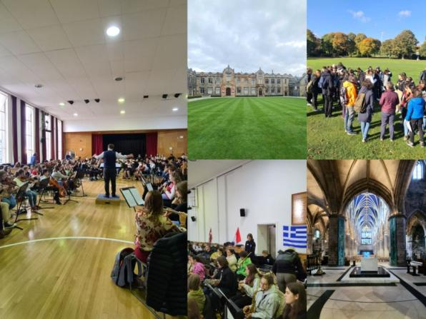
Subsequently, with the extension of the program, the teams were given the opportunity to go ahead with the trips scheduled by the program, since the relevant restrictions had been lifted. So, in October, a group of students from the Music School of Corinth found themselves together with the other five partners participating in the European programme, in Aberdeen, Scotland. Our students met, communicated and collaborated with the other groups, got in touch with Scottish culture and fully realised the European dimension of the programme. More specifically, they visited the sights of the city of Aberdeen, toured the school facilities, participated in both educational and recreational games in AlbynSchool, visited DuthiePark and prepared their main concert at the wonderful facilities of Music Hall in the heart of Aberdeen City. The final product of the collaboration was the realization of a concert where the "Symphony of Europe" was presented for the first time worldwide by more than 150 students, as well as works by composers from each country, with the joint participation and performance of all the children of the programme. With this trip, teachers and students were given the opportunity to visit other major UK cities as well as their most important natural and cultural attractions on their way to Aberdeen. This fact gave them the opportunity to further enrich their knowledge and experiences of the modern European reality.
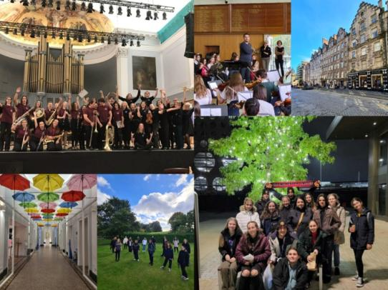
In the same month, the Music School of Corinth traveled to Moletai, Lithuania.
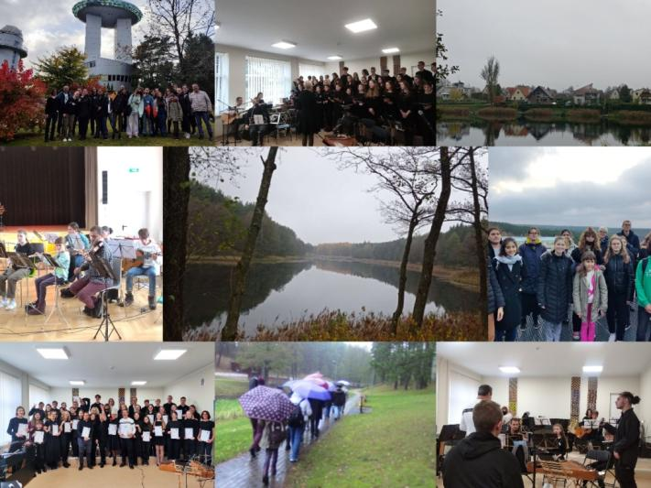
Our students had the opportunity to meet, communicate and perform a diverse musical repertoire with the students of the Lithuanian school. Educational, artistic and recreational activities were carried out there, both inside and outside the school. They visited the ethnocosmological museum of the area, Lithuanian National Opera and Ballet Theatre as well as various natural attractions. Two concerts were held at the school in which the students performed works by composers from the two countries. In this way, friendship, cooperation and trust were developed between the two educational communities, thus becoming aware of the common elements of their cultures.
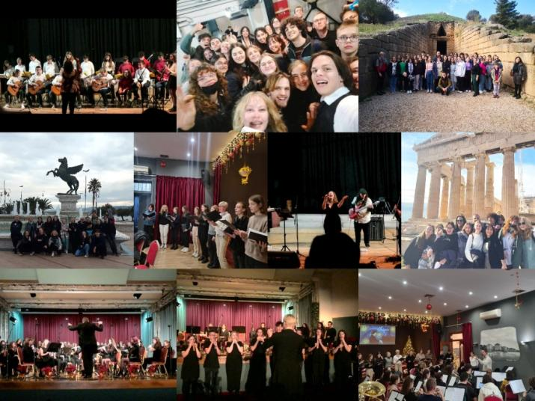
In November, the students of the Moletai school of Lithuania travelled to Greece, thus completing the cycle of movements foreseen by the program. There, the Lithuanian students were guided to the archaeological sites of Athens, Corinth, Epidaurus and Nafplio, got to know the Greek culture and strengthened the friendly ties they had already developed. At the same time, they took part in various recreational activities, with musical and cultural content, learning characteristics of our culture and getting to know elements of our daily life. In addition, the students of Greece and Lithuania participated in the two-day festivities – concerts of the Music School of Corinth, in a packed hall, presenting both joint musical works and representative works of each country. During these events, with the presence of representatives of the local authority, institutions and parents, the students received an enthusiastic applause and experienced both the acceptance and recognition of their efforts, as well as their common European consciousness.
We are all more than satisfied with the implementation of the programme, the procedures followed as well as the final result. We would like to give special thanks to the countries of Scotland and Lithuania for their warm hospitality hoping to be given the opportunity for further collaboration.
